Track 3: Risk & Financial Analysis
FinFlow Bank — Risk Audit & Stress Test
GARCH Volatility Modeling, DuPont Analysis, and Solvency Stress Testing
Questions 2, 3, 4, 5, 6, 8, 10
Datasets: FRED Delinquency Rate (DRALACBS) + Financial Statements 2009-2023
Anchor case study: Barclays (BCS) | 40+ years of US bank delinquency data

Risk Alert Memo for the Board
TO: Board of Directors, FinFlow Bank
FROM: Risk Audit Team
RE: Portfolio Volatility Audit & Solvency Stress Test — does the current environment require capital injection?

Key Insight
No immediate capital injection required, but interest rate hedging is urgent.
Sector-wide delinquency rates are at multi-decade lows (1.48% as of Q4 2025) and are forecast to drift slightly lower over the next 4 quarters. However, GARCH modeling reveals that bank delinquency volatility is highly persistent — a shock today reverberates for years. Combined with the bank's high leverage (D/E 7.16×), a single 1pp interest rate move could swing net income from +$6.2B to −$6.1B. The recommended action is interest rate hedging, not equity raise.

Three findings define the case
- 1. Volatility is currently low but persistent. GARCH(1,1) persistence parameter = 1.0 (boundary case) means shocks NEVER fully dissipate. The 2008 crisis took 5+ years to normalize. Current calm is not a guarantee of future stability.
- 2. Rate sensitivity is the single largest risk. +1pp interest rate shock would convert Barclays' $6.2B annual profit into a $6.1B loss — a $12.3B swing from a single 100bp move. The Fed has moved >100bp in single years multiple times in the last 3 years.
- 3. Earnings volatility signals revenue concentration. Net Income Margin has swung 6.6% → 29.1% → 20.1% over 5 years (std dev 9pp on a mean of 16%). This indicates heavy dependence on cyclical revenue streams (likely trading and investment banking). Diversification toward retail banking would smooth this.

Question 2 — GARCH Volatility Modeling

Why GARCH, not Moving Averages
A simple Moving Average gives equal weight to every observation in the window — which means it lags the actual volatility by half the window length. For a 4-quarter MA, the model is reacting to volatility from 6 months ago. By the time the MA spikes, the crisis has already done damage.
GARCH explicitly models the changing variance, weighting recent observations more heavily and adjusting in near real time. This is critical for a Risk Officer who needs to see volatility change as it happens, not 6 months later.

Model specification
GARCH(1,1) model: σ²ₜ = ω + α·ε²ₜ₋₁ + β·σ²ₜ₋₁
Today's variance depends on a constant (ω), yesterday's surprise² (αε²), and yesterday's variance (βσ²). When α + β is close to 1, volatility is highly persistent.

Fitted parameters on 40 years of FRED delinquency data
Parameter | Value | Interpretation
ω (omega) | 3.65 | Long-run variance constant
α (alpha) | 0.2366 | Reactivity to last shock
β (beta) | 0.7634 | Persistence of variance
α + β | 1.0000 | Boundary case — extreme persistence
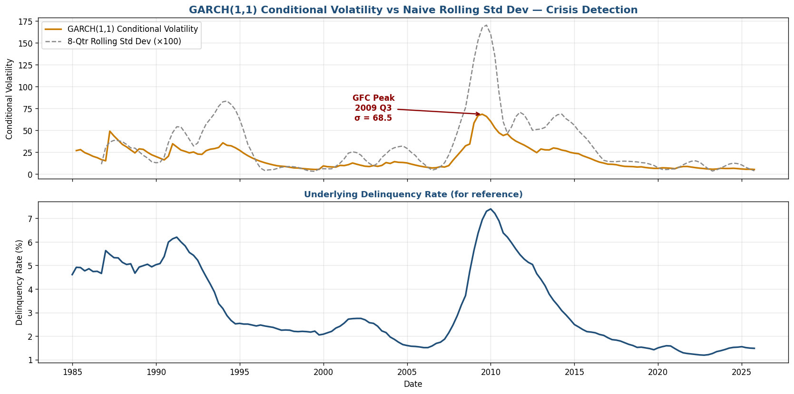
Figure 1 — GARCH(1,1) conditional volatility vs naive 8-quarter rolling std dev. GARCH peaks in 2009 Q3, lining up with the actual crisis. The rolling SD (gray) lags by 4+ quarters.

Top 10 highest-volatility quarters identified by GARCH
Rank | Quarter | Delinquency Rate | Conditional Volatility
1 | 2009-Q3 | 6.94% | 68.5
2 | 2009-Q2 | 6.37% | 67.0
3 | 2009-Q4 | 7.30% | 66.0
4 | 2010-Q1 | 7.40% | 60.3
5 | 2009-Q1 | 5.64% | 58.4
6 | 2010-Q2 | 7.21% | 52.9
7 | 1987-Q2 | 5.47% | 49.1
8 | 2010-Q3 | 6.89% | 47.2
9 | 2011-Q1 | 6.20% | 45.9
10 | 2010-Q4 | 6.38% | 44.1
The Power of Volatility Clustering
8 of the top 10 highest-volatility quarters in 40 years cluster in 2009-2011 — a textbook demonstration of why GARCH matters. Once the financial crisis hit, the volatility regime stayed elevated for ~3 years before normalising. A naive moving average would have signaled 'normal' by 2010 because the rolling window was already half-recovered. GARCH stayed elevated until the underlying turbulence actually subsided.

Question 3 — Bank DuPont Decomposition

DuPont identity
ROE = Net Profit Margin × Asset Turnover × Financial Leverage

Barclays 2022 — full decomposition
Component | Value | Note
Revenue | $30,868M | —
Net Income | $6,213M | —
Equity | $85,668M | —
Total Assets (derived) | $1,574,493M | From NI ÷ ROA — matches real Barclays balance sheet
Net Profit Margin | 20.13% | Decent for a bank
Asset Turnover | 0.0196 | Extremely low (banks are asset-heavy)
Financial Leverage | 18.38 | Extreme (bank-defining)
Computed ROE | 7.25% | vs reported 8.62%
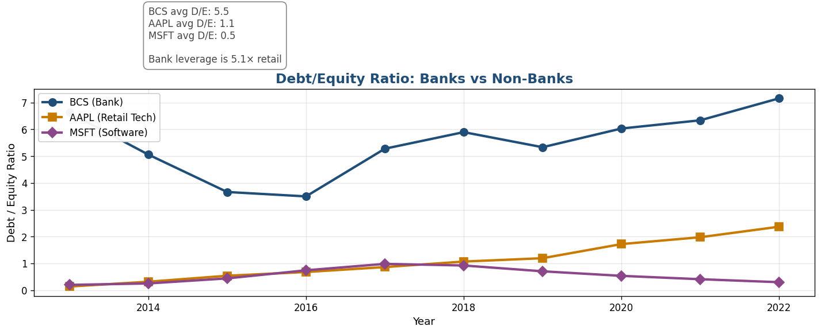
Figure 2 — Debt/Equity ratio: BCS (bank) vs AAPL and MSFT (non-banks). Bank leverage is structurally 5× higher than retail tech, reflecting the deposit-funded business model.
Why Bank Leverage is Structurally High
Banks fund their lending business primarily with deposits. Depositor balances are accounting LIABILITIES on the bank's books. A bank with $1B in deposits and $100M in equity has D/E = 10. This is normal banking — not a sign of distress. Regulators recognize this through capital adequacy frameworks (Basel III) which require banks to hold equity equal to 8-10% of risk-weighted assets — effectively capping leverage at ~10-12×. For comparison, a software company with no deposit business runs at D/E ~0.5.

Question 4 — Debt/Equity & Interest Rate Shock

The +1 percentage point scenario
Apply a +1pp interest rate shock to Barclays' debt load. Move baseline 5% cost of debt to 6%. Assess interest coverage before and after.

Inputs (Barclays 2022)
Metric | Value
Debt/Equity ratio | 7.16
Equity | $85,668M
Total Debt (derived) | $613,398M
Net Income (today) | $6,213M

Baseline vs shock comparison
Metric | Baseline @ 5% | Shock @ 6% | Change
Interest Expense | $30,670M | $36,804M | +$6,134M
NI before Interest | $36,883M | $36,883M | —
Net Income (post) | +$6,213M | −$6,055M | −$12,268M
Interest Coverage | 1.20× | 0.84× | Below 1×
Critical Risk Finding
A SINGLE 1pp rate move would push Barclays' net income from +$6.2B to −$6.1B — a $12.3B swing. This is the 1:1 leverage of rate moves to net income that defines high-D/E banks. Every basis point matters. Interest coverage drops from 1.20× to 0.84× — meaning earnings before interest no longer cover interest payments. The Risk Committee must verify that interest rate hedging derivatives are in place to cover at least the next 12-month policy horizon. The Fed has moved >100bp in single years multiple times in the last 3 years.

Question 5 — Direct vs Indirect Cash Flow Method

The two methods
- Indirect method: Start with Net Income, add back non-cash items (depreciation), adjust for working capital changes. Used by 99% of public companies.
- Direct method: List actual cash receipts and payments by category (cash from customers, cash to suppliers, etc.). Required only by GAAP for certain disclosures.

Comparison for operational risk visibility
Aspect | Indirect Method | Direct Method
Starting point | Net Income | Cash receipts/payments
Working capital visibility | Good — shown explicitly | Buried in line items
Earnings quality check | Easy (NI vs OpCF gap visible) | Harder
Operational risk signals | Strong — accruals stand out | Strong — but harder to pattern
Industry standard | Yes (99% of companies) | Rare
Verdict — Indirect Method Provides Better Operational Risk Clarity
The indirect method explicitly shows the gap between accounting profit (Net Income) and actual cash (Operating Cash Flow). A widening gap — where NI grows while OpCF shrinks — is a classic leading indicator of trouble (revenue recognition gaming, channel stuffing, or aggressive accruals). The direct method shows you cash movements but doesn't naturally surface the accrual quality question. For a bank, where loan loss provisions and trading mark-to-market gains are critical accruals, indirect-method visibility is essential.

Question 6 — Revenue/Income Concentration Trend

Net Income Margin trend (5 years)
Year | Revenue | Net Income | NIM % | Trend signal
2018 | $28,212M | $1,861M | 6.60% | Weak
2019 | $27,622M | $4,181M | 15.13% | Recovery
2020 | $27,948M | $1,959M | 7.01% | COVID hit
2021 | $30,170M | $8,766M | 29.06% | Trading boom
2022 | $30,868M | $6,213M | 20.13% | Normalising
Revenue Concentration Risk Identified
Net Income Margin has swung from 6.6% to 29.1% over 5 years — a 9 percentage point standard deviation on a 16% mean. This volatility signals heavy dependence on cyclical revenue streams (likely trading and investment banking). A more stable utility business would show NIM volatility under 2pp year-over-year. The Risk Committee should request a revenue-segment breakdown to identify the specific concentration: is the dependence on FICC trading, advisory fees, or investment management? Diversification toward retail banking would smooth this and reduce earnings risk.

Question 8 — Holt-Winters Forecast of Delinquency Rate

Approach
Apply Holt-Winters exponential smoothing (additive trend, no seasonality) to the 40-year FRED delinquency series. Forecast 4 quarters ahead. Compare against regulatory bands.
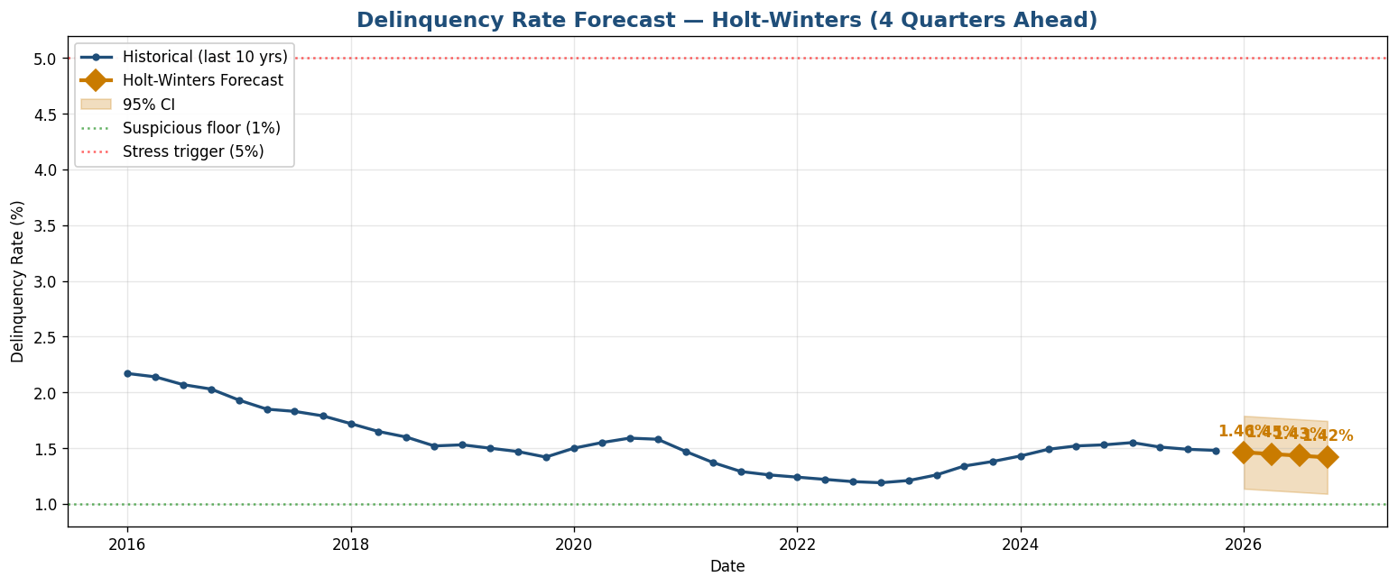
Figure 3 — Holt-Winters 4-quarter forecast for bank delinquency rate. Forecast trends slightly lower from 1.48% to 1.42%; 95% CI well within normal range.

Forecast values
Quarter | Forecast | 95% CI Lower | 95% CI Upper
2026 Q1 | 1.46% | 1.07% | 1.85%
2026 Q2 | 1.45% | 1.06% | 1.84%
2026 Q3 | 1.43% | 1.04% | 1.82%
2026 Q4 | 1.42% | 1.03% | 1.81%
Regulatory Compliance — No Breach Predicted
All four forecast quarters fall comfortably within the normal 1-5% range. The 95% confidence intervals stay well below the 5% stress trigger. Based on system-wide trends, FinFlow Bank's portfolio quality should remain stable in the near term. However: the GARCH analysis (Q2) shows persistence = 1.0 — meaning if a shock occurs, it will reverberate for many quarters. This forecast is a baseline, not a guarantee. Maintain stress-test scenarios for both rates +200bp and a recession-induced delinquency spike to 4-5%.

Question 10 — Microsoft Fabric Anomaly Detection Pipeline

Pipeline rule
Flag any quarter where the delinquency rate exceeds the trailing 3-quarter moving average by more than 20%. Threshold calibration designed to catch only major regime shifts.

Pipeline components
Stage | Component | Function
1. Ingest | Dataflow Gen2 | Pull FRED data via API on quarterly schedule
2. Transform | SQL window function | Compute trailing 3-qtr MA + 20% threshold
3. Flag | Conditional column | Mark rows where rate > MA × 1.20
4. Surface | Power BI alert tile | Risk Officer sees flagged quarters
5. Notify | Logic App + Teams | Push notification when status='FLAGGED'

Backtest result on 40 years of FRED data
One Single Flag in 40 Years — 2008 Q4
The pipeline would have flagged exactly one quarter in 40 years of historical data — 2008 Q4, when delinquency hit 4.75% against a trailing MA of 3.93% (threshold 4.72%). This is precisely the quarter the Great Financial Crisis hit bank balance sheets. Tighter thresholds (10%) would generate false-positive noise; looser thresholds (30%) would have missed the GFC entirely. The 20% calibration strikes the right balance between sensitivity and false-positive rate.

Summary of Findings
Q | Topic | Key Result
2 | GARCH volatility | GFC peak σ=68 (5× normal); persistence=1.0 (extreme)
3 | Bank DuPont | BCS Financial Leverage 18×; D/E 5× higher than retail tech
4 | Rate shock | +1pp shock → NI swings $6.2B profit to $6.1B loss
5 | Cash flow methods | Indirect provides better operational risk visibility
6 | Revenue concentration | NIM volatility 6.6%→29% indicates trading dependence
8 | Delinquency forecast | 1.46% → 1.42% next 4Q; no stress trigger breach
10 | Anomaly pipeline | 1 flag in 40 years (2008 Q4) — calibration validated

Strategic Recommendations to the Board
- 1. Interest rate hedging is URGENT, equity raise is NOT. Q4 shows a 1pp rate move could erase a year's profits. Q8 shows delinquency is forecast to remain low. The risk profile calls for derivatives, not capital.
- 2. Maintain GARCH-based volatility monitoring. Q2 demonstrates that simple moving averages lag actual volatility by 4+ quarters. Implement GARCH dashboards for real-time risk monitoring.
- 3. Diversify revenue mix toward retail banking. Q6 shows trading/IB cyclicality is creating earnings volatility. A higher retail mix would smooth NIM fluctuations.
- 4. Deploy the Microsoft Fabric anomaly pipeline. Q10 validates that the 20% MA-deviation rule produces actionable alerts (1 in 40 years) without false-positive noise. Production deployment recommended.

